A Binned-Profile Approach to the Color Blending Problem

in Transparent See-Through Displays

Author 1*

Organization or School

Abstract

See-through displays allow users to view both digital content and physical objects at once. In such displays, light coming from background objects mixes with the light originated in the display, causing what is known as the color blending problem. Color blending is an important issue for the wider adoption of see-through displays and AR in general as it affect the legibility and color encodings of digital content, with a negative impact on the general usability of such displays. Color preservation aims at reducing the impact of color blending by finding an alternative color which, once blended with the background, would result in the original color. At the heart of color preservation is the capacity to predict how digital and background colors blend for a particular display.

In this paper we propose the binned-profile model for color prediction and preservation in see-through displays. The binned-profile model is based on the observations that each display renders colors differently and that background colors are changed by the display medium before blending. For a given display the model uses a colorimetric profile of how such display shows colors; with colors binned to a small set of “noticeably different” colors. We validate our model by measuring the accuracy of the predictions against other prediction models (direct model and chromatic adaptation transformations). Then, we introduce a color correction algorithm and measure the accuracy of the corrections. We investigated our approach with an extensive set of digital and background colors and different hardware configurations (projector-based and OLED displays). Finally, we elaborate on the usability and design implications of our approach for color preservation.

**Keywords**: Color Blending, Optical See-through Displays, Color Binning, Color Correction, Color Perception.

**Index Terms**: H.5 [Information Interfaces and Presentation]: H.5.1: Multimedia Information Systems — Artificial, Augmented, and Virtual Realities; H.5.2: User Interfaces — Ergonomics, Evaluation / Methodology, Screen Design, Style Guides

# Introduction

See-through displays allow users to view both digital content and physical objects at once. They come in multiple form factors (e.g. optical head mounted displays or projection-based) and are used in augmented reality (AR) as a way to enhance the real world with digital information. Although other technologies can be used for AR purposes (e.g. video-based displays), see-through displays have the advantage of letting users see the real world with their own eyes, without reducing its fidelity and preserving properties like lighting, texture, color, age and wear. Researcher have used see-through displays for a wide range of applications including X, Y, Z (see [1][2][3] for a comprehensive list of applications); and a few consumer electronics have started to adopt them [5]. We can expect wider adoption of such technologies with the introduction of novel mobile AR platforms like Google Glass [], and the continuous development of transparent LCD (Samsung NL22B [[link](http://www.samsung.com/us/business/commercial-display-solutions/LH22NLBVLVC/ZA)], Eyevis [[link](http://www.eyevis.de/index.php?article_id=163&clang=1)], RichTech [[link](http://www.richtechsystem.com/html/transparent-video-showcase.html)]) and OLED displays (Futaba Corporation [[link](http://www.oled-info.com/futabas-oled-road-map-amoleds-2014-transparent-and-flexible-oleds-cars-2015)], Fujitsu [[link](http://www.fujitsu.com/be/Images/Workplace_of_the_Future.pdf)], Winstar [[link](http://www.winstar.com.tw/newspaper_ov.php?lang=en&ID=153)]).

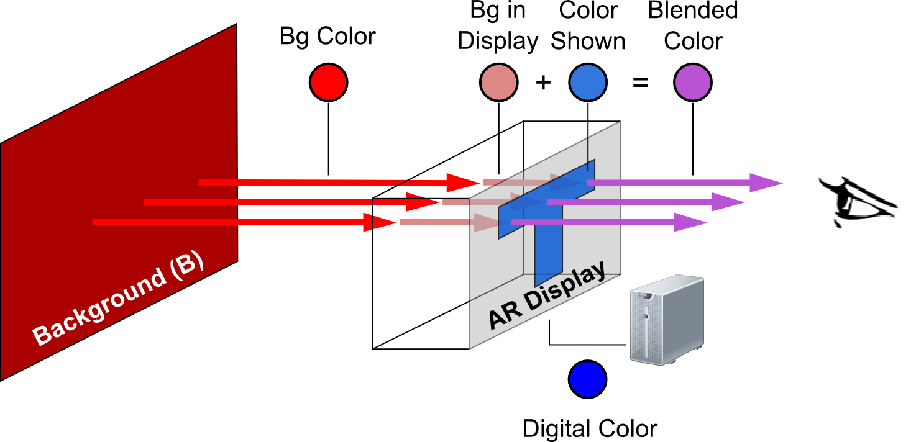

Figure 1. Color blending including the screen distortions for background and digital colors.

An important aspect of optical see-through displays is that background light coming from real-world object mixes with the light emitted by the display, something that has been described as color blending [1]. Color blending is an important phenomenon as it can affect the legibility and color-encoding of digital informa-tion, and compromise the general usability of such devices. Gabbard et al. studied color blending and modeled the problem … Color blending is al present in other technologies like projector-based spatial AR. Despite being a widely acknowledge problem for the adoption of see-through displays and general AR applications, little research exists on how to preserve digital colors exposed to color blending. To preserve a digital color a system should find an alternative digital color which, upon blending with such background, comes closest to the desired digital color. Existing solutions, particularly from the field of spatil AR, consist in an iterative process of correcting the digital output and measuring the resulting projection. PROBLEMS WITH THIS APPROACH.

LEAVE 0.5 INCH SPACE AT BOTTOM OF LEFT COLUMN ON FIRST PAGE FOR COPYRIGHT BLOCK

* email address

An effective approach to preserve digital color in see-through displays relies on its *prediction* accuracy, i.e. the capacity to estimate the blend resulting from a given background and digital colors and for a particular display. In this paper we argue that high prediction accuracy requires taking into account two distortions introduced by the display and shown in Figure 1: (1) the way a particular display renders colors, and (2) the effect of the display media on the background color. To address the first distortion we propose the binned profile prediction model: a model that divides the continuous universe of colors into discrete and finite bins and measures how the display actually renders each bin. To address the second distortion we measure the background color only after passing through the display. We compared our model with other approaches to the *direct model*, the *chromatic adaptation transformation* (*CAT) model*. The direct model ignores the effect of the display on the digital colors; the CAT model uses known transformation matrices to determine the way a display shows particular colors.

We used a colorimeter to measure the accuracy of the different prediction models on three transparent see-through displays. Results showed that a binned profiled-based with modified background prediction outperforms other methods by min XX *just-noticeable differences* (JNDs). Further, we compared the accuracy of color preservation using the binned profile model against using the direct model, with and without the effect of the display on the background. Results showed our model outperforms the direct model correcting a wider range of colors and with higher accuracy.

This paper contributes to the field of augmented reality in several ways: 1) we propose a novel approach to color prediction and preservation for optical-see through displays; 2) we validate our approach against other possible solutions; 3) we discuss the implications of color blending for situations where color preservation is not possible or contrast preservation is preferred; and finally 4) we discuss the challenges associated to incorporating our algorithm into everyday optical see-through display platforms.

# Background [1 column]

Describe color blending based on Gabbard et al.

Show Gabbard’

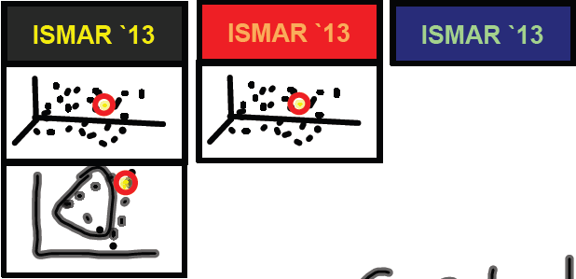

Figure 2. Examples of color blending

[Figure with Images Color Blending]

Describe what happens in the image (lay our Gabbard’s formula for color blending).

Introduce the Lab color space

Laid out then our formulation of color preservation.

# Related Work [1 Column]

## Field-studies of augmented reality.

Relocation of content,

Using the hand to create contrast

## Color Correction

Colorimetric compensation in projector-based see-through displays.

Color correction in projector-based spatial augmented reality

## Occlusion

1. Increase the intensity of the digital content (mentioned by Koyikawa)
2. Use LCD to block background light: B/W LCD (Koyikawa – optical s-t display for mutual occlusion), Grayscale LCD (Zhou et al. Novel Optical S-T HMD), spatial light modulator - SML (Cakmakci et al. a compact OST HMD)
3. Illuminating only the parts of the real objects that will not mix with the digital content (requires dark room) [Noda el at – rangefinder, Bimber et al.’s occlusion shadows]
4. Screens behind the real objects [Inami – visio-haptic display]

# Experimental Test-Bed

Box

Colorimenter

LCD as a background generator (discuss image)

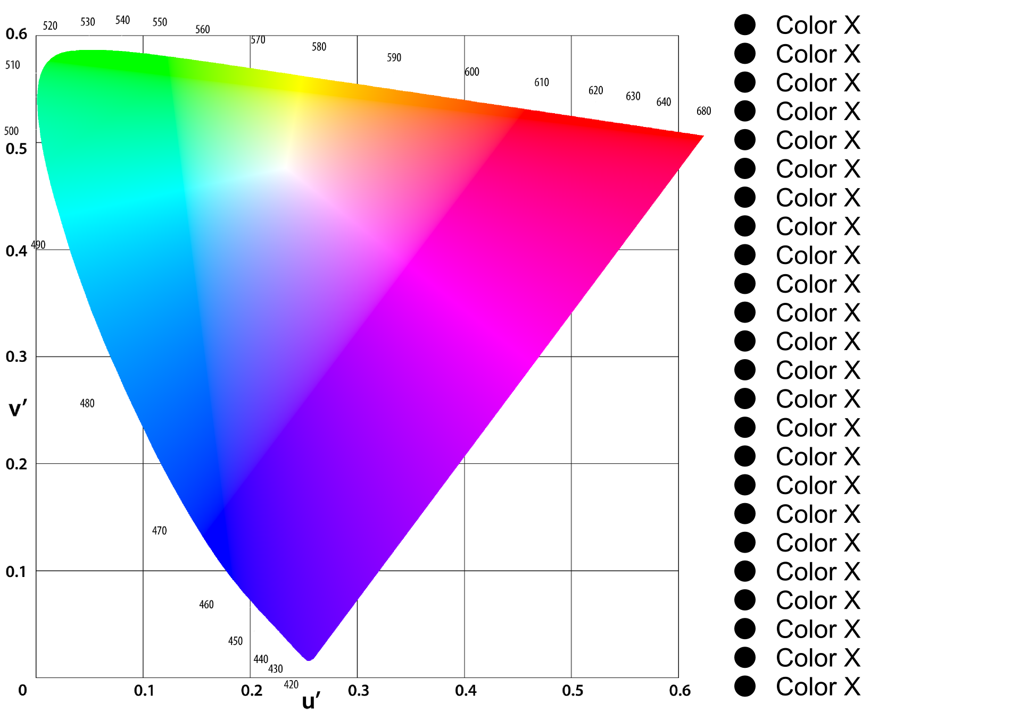

Figure 3. Background color set in the experimental set-up.

Projector display 1

Projector display 2

OLED display

Software

# Color Prediction

Direct Model (show the binned-color space)

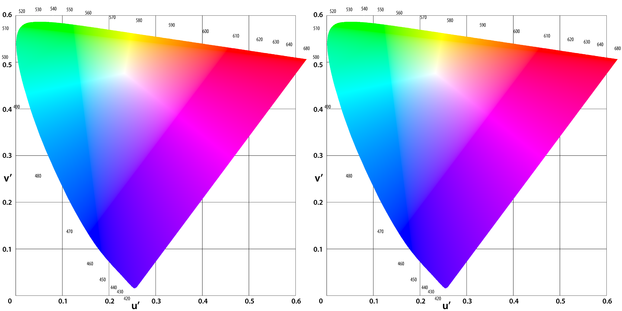

Figure 4. Left: The digital color #FF0000 and as displayed by different optical see-through displays. Right: The background color, and as it is seen through different optical see-through displays.

However, the colors involved in the blending differ from the “pure” ones assumed by the direct model. Figure 3-left shows

Show the new conception of color blending as presented in figure 4.

Say that to investigate this effect we took two approaches: cat and binned profile.

CAT (show image with the three cats for each display 3x3)

Binned-profile (show image with the binned-profile of each display), say that we are interested in this given the high variation of the CAT profiles. Tell hw we built each profile. Say that a limitation of this approach is the memory overhead (bytes per color pair).

## Data Collection

Describe how we collected data for each display

Describe how we computed the blending prediction for each model.

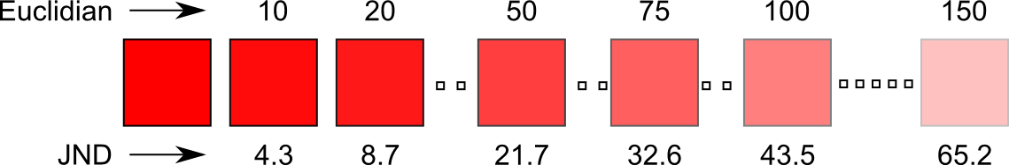

Figure 5. Examples of Euclidian distances and their corresponding just-noticeable difference.

## Results

Show one sample 3D image for a given display with the direct model and the binned profile to demonstrate the differences in the blue dots.

Show the BIG bar charts image (5 models X 3 displays X 27 backgrounds)

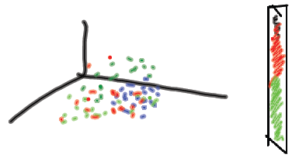

Figure 6. Single prediction result

# Color Preservation

Correctable range (by bg color)

# Discussion

Colors that can be corrected regardless of the background

Camera-based color correction

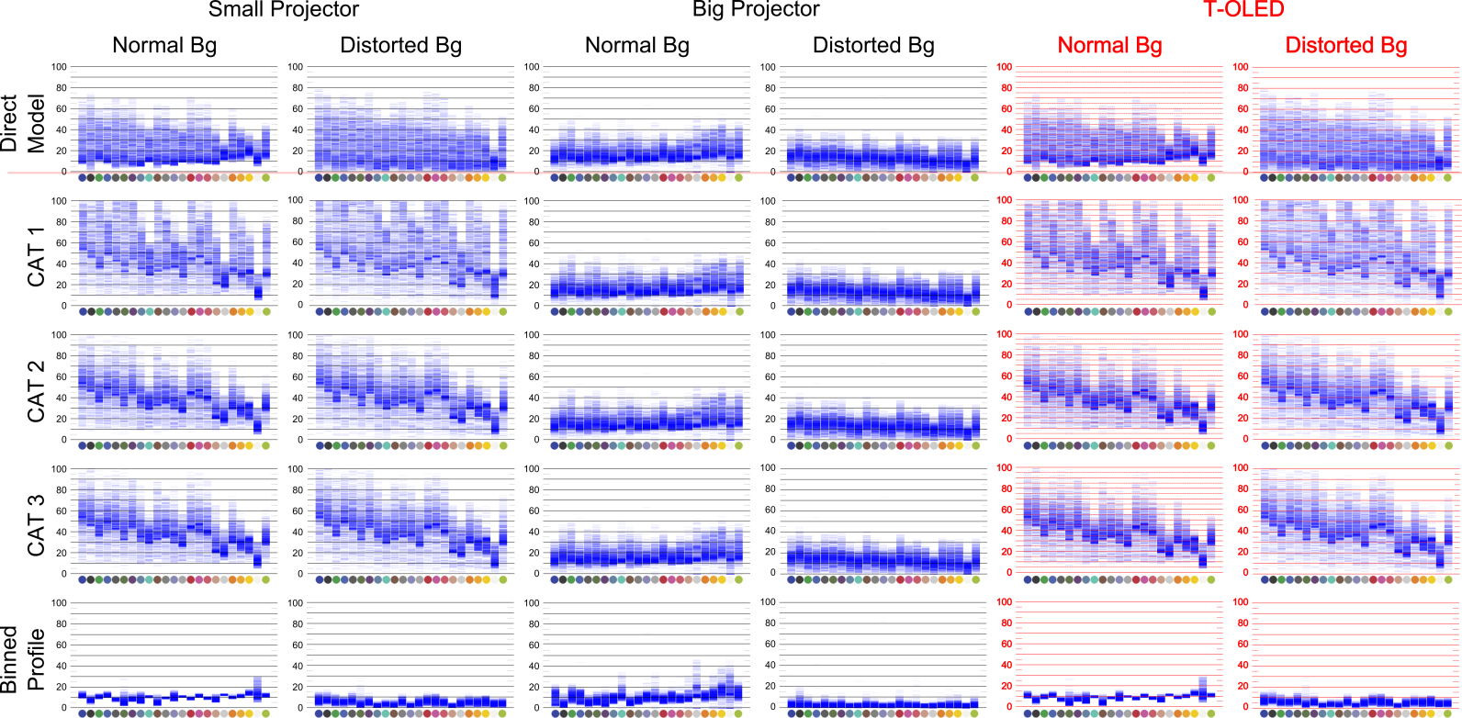

Figure 7. Prediction results

# Conclusions

References

1. Azuma, R., Baillot, Y., Behringer, R., Feiner, S., Julier, S., and MacIntyre, B. 2001. Recent Advances in Augmented Reality. IEEE Comput. Graph. Appl. 21, 6.
2. Bimber, O. and Raskar, R. 2005. Spatial Augmented Reality: Merging Real and Virtual Worlds. A. K. Peters, Ltd., Natick, MA, USA.
3. Carmigniani, J., Furht, B., Anisetti, M., Ceravolo, P., Damiani, E., and Ivkovic, M. 2011. Augmented reality technologies, systems and applications. Multimedia Tools Appl. 51, 1 (January 2011), 341-377.
4. Gabbard, J.L., Swan, J.E., Zedlitz, J., and Winchester, W.W. 2010. More than meets the eye: An engineering study to empirically examine the blending of real and virtual color spaces. In Proc. VR '10. IEEE, Washington, DC.
5. GSM arena. (2013, March 19). Lenovo S800 – Full phone specifications. (2011) [Website]. Retrieved from <http://www.gsmarena.com/lenovo_s800-4862.php>.